Assignment – 6
Sentiment analysis using LSTM network or GRU

Problem Statement:
The objective of this assignment is to implement Sentiment Analysis using an LSTM (Long Short-Term Memory) network or a GRU (Gated Recurrent Unit). Sentiment analysis is a natural language processing task that involves determining whether a piece of text (such as a review, tweet, or comment) expresses a positive, negative, or neutral sentiment. Recurrent Neural Networks (RNNs), especially LSTMs and GRUs, are highly effective for this task due to their ability to capture long-term dependencies in sequential data.

Software used:
- Python 3.x
- Google Colab

Libraries and packages used:
- tensorflow / keras: For building the LSTM/GRU model.
- pandas: For loading and preprocessing the dataset.
- numpy: For numerical computations.
- matplotlib: For visualizing the results.
- nltk / spacy: For text preprocessing (tokenization, stop word removal).
- sklearn: For splitting the dataset and calculating performance metrics.

Theory:
Sentiment Analysis is the process of using natural language processing (NLP) techniques to analyse the sentiment expressed in text. It is widely used in applications such as analysing customer reviews, social media sentiment, and feedback surveys.
LSTM (Long Short-Term Memory) networks and GRUs (Gated Recurrent Units) are types of recurrent neural networks (RNNs) designed to capture long-term dependencies in sequential data. LSTMs and GRUs overcome the vanishing gradient problem in standard RNNs, allowing them to better learn from longer sequences of text, making them suitable for tasks like sentiment analysis.
- LSTMs use gates (forget, input, and output gates) to control the flow of information in and out of the cell, effectively retaining important information across time steps.
- GRUs simplify the LSTM architecture by combining the forget and input gates into a single update gate, making them computationally more efficient.

Methodology:
- Data Collection: Collect a dataset containing text labelled with sentiments (positive, negative, neutral). Common datasets include IMDb movie reviews, Twitter sentiment dataset, or Yelp reviews.
- Data Preprocessing:
- Tokenize the text data and remove stop words.
- Convert the text into sequences of numbers using word embeddings (e.g., Word2Vec, GloVe, or Keras’s Tokenizer).
- Pad sequences to ensure uniform input length.
- Model Design:
- Choose between LSTM or GRU for modelling.
- Build a sequential model with an embedding layer, an LSTM/GRU layer, and a dense output layer with SoftMax activation for classification.
- Model Training: Train the model on the training dataset using cross-entropy loss and evaluate it on the test set.
- Evaluation: Evaluate the model performance using accuracy, confusion matrix, and F1-score.

Advantages:
- Effective for Long Sequences: LSTMs and GRUs capture long-term dependencies, making them well-suited for text data.
- Versatile: Can be applied to a variety of NLP tasks, including text classification, sentiment analysis, and translation.
- Handles Sequential Data: Capable of processing variable-length sequences of text.

Limitations:
- Computationally Intensive: LSTM and GRU networks require significant computational power and memory, especially for large datasets.
- Training Time: These models can take longer to train due to their complexity.
- Sensitive to Data Quality: Model performance can degrade with noisy or unclean text data.

Applications with example:
- Movie Review Analysis: Analysing the sentiment of IMDb movie reviews to classify them as positive or negative.
- Social Media Monitoring: Analysing sentiment in tweets to understand public opinion on a trending topic.
- Customer Feedback: Analysing product reviews to identify sentiment towards a product or service.
Example: Classifying movie reviews from the IMDb dataset as positive or negative.

Working / Algorithm:
- Data Preprocessing: Load the dataset and preprocess the text (tokenization, stop word removal, and word embedding).
- Model Design: Build an LSTM or GRU model with word embeddings and dropout regularization.
- Model Training: Train the model on the training set and monitor the accuracy and loss on the validation set.
- Evaluation: Evaluate the model on the test set using performance metrics such as accuracy and confusion matrix.

Diagram:

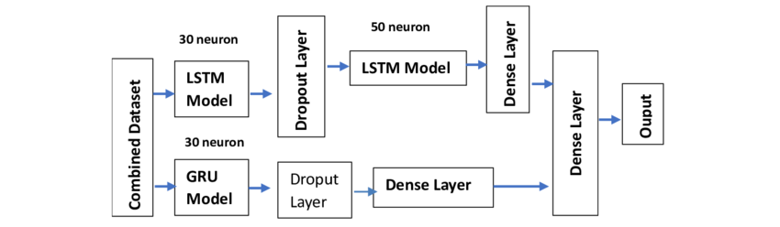

Conclusion:
In this assignment, we implemented sentiment analysis using LSTM and GRU models. These models are effective at learning long-term dependencies in text data, making them ideal for sentiment analysis tasks. We demonstrated how to preprocess text, build and train the model, and evaluate its performance using accuracy and confusion matrices. LSTMs and GRUs provide robust solutions for various natural language processing tasks and can be extended to other applications such as text classification and language modelling.

